**PHY 102**

**Electromagnetic induction:** It is the production of current or voltage whenever there is a relative motion between the conductor and the magnetic field (or magnet). This process causes induction of e.m.f in the circuit. The induced e.m.f depends on the speed (motion) of the magnet, number of turns on the coil and the strength of the magnet.

Magnetic line of force is produced by the magnet, the Induced e.m.f (ε) = Blv

where B, v and the conductor are all perpendicular to one another.

The induced e.m.f increases with increasing

1. the speed of motion of the conductor or the magnet
2. the number of turns on the coil and
3. the strength of the magnet.

Experiment to verify laws of electromagnetic induction

A solenoid is produced by winding several turns of coils of insulated copper wire. Connect the solenoid to a galvanometer. Move the n-pole of the magnet toward the end of the coil. Note the direction of the galvanometer. Move the magnet away from the coil and note the new direction. Then, keep the magnet stationary in the coil. When a bar of magnet is drived into a coil connected to a galvanometer, the galvanometer deflects in a particular direction as shown in figure A.

Current will flow in the galvanometer whenever there is relative motion between the coil and the magnet (when magnet moves toward or away from the coil). Such current is called induced current. When the magnet remained stationary in the coil, the galvanometer gives no deflection showing that no current is flowing through it.

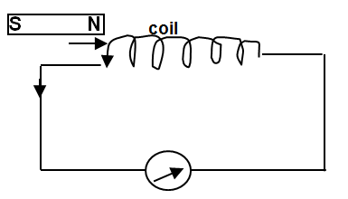Figure A

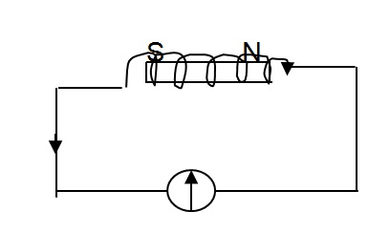Figure B

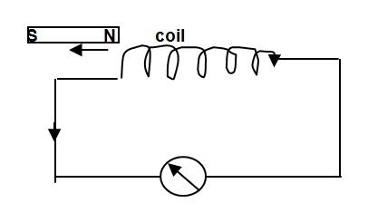Figure C

Note: any relative motion between coil and a magnet produced an induced current or e.m.f is generated in the coil. The direction of the induced current depends on the polarity and movement of the magnet. The faster the relative motion, the greater size of the induced current. Increase in the strength of the magnet and increase in the number of turns of the coil all increase the size of the induced current.

Faraday‘s Law of Electromagnetic Induction

Faraday’s Law

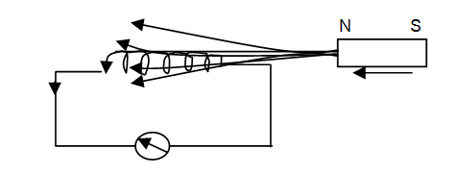

1st law:-An e.m.f is induced whenever there is flux leakage. When the magnetic flux linking a circuit is changing an e.m.f is induced in the circuit.

2nd law:- The magnitude of the induced e.m.f is proportional to the rate of change of the magnetic flux linking the circuit. ε = - N 

The magnetic flux Φ = BA

The flux linkage = NBA

(N = number of turns in the coil, B = flux density, A = cross sectional area)

Where A is the cross-sectional area of the coil and N is the number of turns of the coil

**Lenz’s Law:** an induced emf flows in such a direction as to oppose the motion producing it. The minus sign in Faraday’s law is consequence of the **Lenz’s Law**

ε = - 

**Direction of induced Current (Flemming Rule)**

Right hand rule states that if the thumb, the fore finger (F) and the middle finger (I) of the right hand are held at right angles to each other and the F points in the direction of field, thumb is in direction of motion, then I points in the direction of the induced current. The induced e.m.f is maximum when the conductor moves at right angle to the lines of magnetic field and zero when the conductor moves parallel to the lines of magnetic field.

The induced e.m.f in a conductor of length l, moving with velocity, v, perpendicular to a field of magnetic induction B is given by E.m.f = Blv

Example

A coil of 10 turns and cross-sectional area 5cm2 is at right angles to a flux density 2 × 10-2T which is reduced to zero in 10s. Find the flux linkage and the induced e.m.f.

**Solution**

The flux linkage = NBA

N = number of turns in the coil = 10

β = flux density = 2 × 10-2T

A = cross sectional area= 5cm2 = 5 × 10-4 m

Flux linkage = 10 × 2 × 10-2× 5 × 10-4 = 1.0 × 10-4Wb

The change in time is 10s, and so the induced e.m.f is:

 = 1.0 × 10-5V

**Example:** A 100 turn coil whose resistance is 6Ω encloses an area of 80 cm2. How rapidly should a magnetic field parallel to its axis change in order to induce a current of 1mA in the coil?

#### Solution

The required emf ε = IR = 10-3× 6 = 6 × 10-3V

Area of a turn is A =  = 8 × 10-3 m2

ε = N  = NA 

 =  =  = 0.0075 Ts-1

**The principles of the motor and generator**

When a coil is rotated between the poles of the permanent magnet, a current is induced in the coil. Two slip rings are connected to the ends of the coil. Two carbon brushes make contact with the slip rings. Current induced in the coil passes out through one brush during one half cycle and out through the other brush during the second half-cycle. The current produced is therefore alternating current; this is a simple a.c. dynamo or generator. By replacing the slip rings with a split ring commutator the a.c. dynamo is then converted to a d.c. dynamo.

By passing a current through a d.c. dynamo, the dynamo will become an electric motor. The constructions of both are the same. In the case of a motor, electrical current is supplied to turn the coil whereas in the dynamo the coil is turned, usually by mechanical means and electric current is produced.

The simple dynamo produces a low emf. To increase the emf and produce a practical instrument then wind the coil on a soft iron armature; increase the number of turns in the coil; turn the coil faster and increase the strength of the field magnet

**A.C. Generator**

A.C. generator (alternating current) is a device for converting mechanical energy into electrical energy. The mechanical energy is produced by the motion of the coils of wire in a magnetic field. The electrical energy is derived from the e.m.f current, which is induced in the coil. It is alternating because it flows in one direction during one part of the cycle and in the opposite direction during the rest of the cycle. It operates on Fleming’s right hand rule

The a. c. generator consists of;

1. A magnet which provides a strong magnetic field
2. An armature consisting of several turns of wire wounds on a soft iron core.
3. Two slip rings on which two carbon brushes rest.

The armature is free to revolve on the axis between the poles of the magnet.

The slip rings are connected to the ends of the armature. The two carbon brushes lead current away from the ring into external circuit.

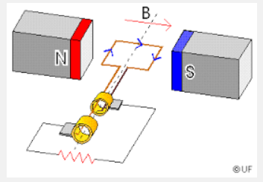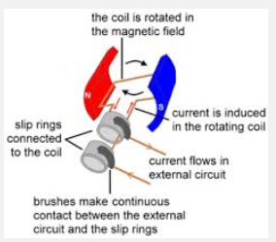

**Shematic of a.c. generator**

As the armature coil rotates between the magnets, the magnetic lines of force through the armature coil change continuously and current is induced in the coil.

The current on both sides of the coil is the same when in horizontal position. No lines of force link it but rate of change of flux is maximum. Hence maximum induced e.m.f. is available at the terminals. In vertical position, lines of force are maximum but rate of change of flux is zero in between the current.

**AC curve**

**D.C. Generator**

For the d.c.generator the induced current produced flows only in one direction. To convert a.c generator to d.c.generator the slip rings are replaced by split rings or commutator, and direct current is produced. To increase the magnitude of the direct current, many coils plus commutator with many segments are used.

To increase a.c. or d.c. current;

1. Increase the number of turns in the coil
2. Increase the flux (use powerful magnets)
3. Winding the coil on soft iron core
4. Increasing the rate of rotation of the coil

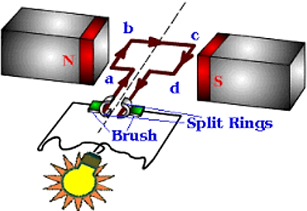

DC generator

E/V

t/s

Current in d.c. generator

The maximum induced e.m.f. Emax= NABω

But ω = 2πf

The maximum induced current Imax = Emax/R

The induced e.m.f. as a function of time E = Emax sinωt

The induced current as a function of time I = Imax sinωt

**Self Inductance**

When the current in a circuit changes, the magnetic field enclosed by the circuit also changes, and the resulting change in flux leads to a self-induced e.m.f given as:

Self induced e.m.f ε = -L 

where is the rate of change of the current and L is the property of the circuit called its self-inductance. The minus sign indicates that the direction of ε is such as to oppose the change in the current dI that caused it. Unit of inductance is the henry (H)

The energy E stored in an inductor is given by E = ½ LI2

**Mutual Inductance**

It is the flow of induced current or voltage in a coil due to an alternating current in another coil. When two coils are in proximity, the mutual inductance M, between the coils is defined as the induced e.m.f in one coil when the current changes in the second coil. That is;



Thus ε2 = m

 = M 

The inductance can be found from



The flux 

Magnetic force F = qvB B = $\frac{μ_{o}I}{2πr}$

**The Transformer**

Transformer is a device that can be used to increase (step-up) or decrease (step-down) voltage. In the step-down transformer, the number of turns in the primary coil is more than the number of turns in the secondary coil. When it is used to step-up voltage, the number of turns in secondary coil are more than the number of turns in primary coil. A transformer changes alternating voltage from low to high values and vice versa. It consists of

1. a primary coil to which the voltage Vp is connected (input voltage)
2. a secondary coil (output) from which the new voltage Vs is obtained.
3. a soft iron laminated core on which both coils are wound.

Ways by which energy is lost in a transformer

1. Heat losses: this is brought about as a result of wire of high resistance. It can be minimized using wire of low resistance
2. Flux leakage: some energy is lost due to leakages of magnetic flux. This is as a result of not all lines of induction due to current in the primary coil passes to the secondary coil. This is brought about as a result of non-efficient core. It can be minimized by using designing efficient core.
3. Eddy current: this is caused by magnetic flux variation. It can be minimized by laminating the iron core.
4. Hysteresis loss: this is as a result of reversing the magnetization of the core. It is reduced by the use of special core of the primary coil or by the use of soft iron cores. It is because of the above losses that the efficiency of transformer is less than 100%.

Efficiency = $\frac{output power}{input power} x 100\%$ **= $\frac{power in the secondary coils}{power in primary coils} x 100\%$**

Primary Secondary

Np turns NS turns

$\frac{Secondary e.m.f}{primary e.m.f}= \frac{no of turns in the secondary coil}{no of turns in the primary coil}$

$\frac{E_{s}}{E_{p}}= \frac{N_{s}}{N_{p}}$ = $\frac{I_{p}}{I_{s}}$

If no loss of energy the power going into a transformer Pp = IpVp must be equal to the power Ps = IsVs going out of the transformer.

##### Example

A transformer connected to a 120V ac power line has 200 turns in its primary winding and 50 turns in its secondary winding. The secondary is connected to a 100Ω light bulb. How much current is drawn from the 120V power line?

#### Solution

The voltage across the secondary is given as:

Vs = Vp = × 120 = 30V

The current Is =  =  = 0.3A

Also current in the primary is given as

Ip = Is = × 0.3 = 0.075A

##### Example

1. How much energy is stored in a 20-mH coil when it carries a current of 0.2A?
2. What should the current in the coil be in order that it contains 1J of energy?

**Solution**

(i) Energy W = ½ LI2 = ½ × 20 × 10-3× (0.2)2 J

W = 4 × 10-4J

(ii) =  = 10A

#### Example

A 0.1H inductor whose resistance is 20Ω is connected to a 12V battery of negligible internal resistance (i) what is the initial rate at which the current increases (ii) what happens to the rate of current increases (iii) what is the final current?

**Solution**

1. Induced emf ε is in the opposite direction to the battery E. Thus the p.d across the inductor at any time is



Initially t = 0, I = 0 thus  and 

1. Since ; thus as the current I increases its rate of change  decreases.
2. When the current has reached its final value 

#### Example

(a) Calculate the inductance of a solenoid containing 250 turns if the length of the solenoid is 20.0cm and its cross-sectional area is 4.00×10-4m2.

(b) Calculate the self-induced e.m.f. in the solenoid described in part A if the current through it is decreasing at the rate of 40.0A/s.

**Solution**:

(a) The inductance can be found from



The flux through each turn is







#### Example

An AC generator consist of 10 turns of wire of area A =0.08m2 with a total resistance of 16.0Ω. The loop rotates in a magnetic field of 0.600T at a constant frequency of 50.0Hz.

(a) Find the maximum induced e.m.f.

(b) What is the maximum induced current?

(c) Determine the induced e.m.f. as a function of time.

(d) Determine the time variation of the induced current.

**Solution:**

(a) ω = 2πf = 2π (50.0Hz)=100π = 314rad/s

Emax= NABω =10(0.08m)(0.6T)(314rad/s) =151V

(b) From Ohm’s law and the result in part A, we find that



(c) E = Emax sinωt =(151V)sin314t where t is in seconds

(d) I = Imax sinωt

=(9.4A)sin314t

#### Example

A long, straight wire carries a current of 4.00A. At one point, a proton, 5.00 mm from the wire travels at 2.00×103 m/s parallel to the same direction as the current. Find the magnetic force that is acting on the proton because of the magnetic field produced by the wire.

**Solution:**



The magnitude of the magnetic force on the proton is:

F = qvB = (1.60x10-19C)(2.00x103m/s)(1.60x10-4T)

=5.12x10-20N

The force is directed at right angle toward the wire

#### Example Find the turn ratio in a transformer which delivers a voltage of 120 Volts in the secondary coil from a primary voltage of 60 Volts.

Turns ratio = Ns/Np

Es/Ep = Ns/Np = 2

A transformer has 50 turns in the primary coil and 30 turns in the secondary coil. If the primary coil is connected to a 220 V mains, what voltage will be obtained from the secondary coil.

Es/Ep = Ns/Np

Es = Ep x Ns/Np

= 220 x 30/50

=

(i) **Faraday’s law** states that an EMF is induced in a coil when there is a change in the magnetic flux through the coil. EMF = -N∆Ф/∆t

(ii)**Lenz’s law** state that the induced current produced by induced EMF in a coil flows in a direction so as to oppose the charge producing it.

(iii) **Mutual inductance** occur when EMF is induced in coils due to change in current flowing in the coils

EMF induced = M∆I/∆t, M = constant of proportionality of mutual inductance measure in Henry, ∆I= change in current

(iv) **Self inductance** occur when a changing current in a coil leads to EMF induction in a cell, the induced EMF = L∆I/∆t where L is the constant of proportionality.

Biot-Savart law states that the magnetic field dB at point P due to current carrying element ds carrying a steady current I is given as.



Where x is the distance from the element to the point P, μ0 = permeability of free space.

The expression for magnetic field in a straight wire conductor B = μ0I/2πx

The expression for magnetic field in an ideal solenoid, B=μ0 NI/L,

where r is the radius of the coil

N= no of turn of coil,

L = length of the coil